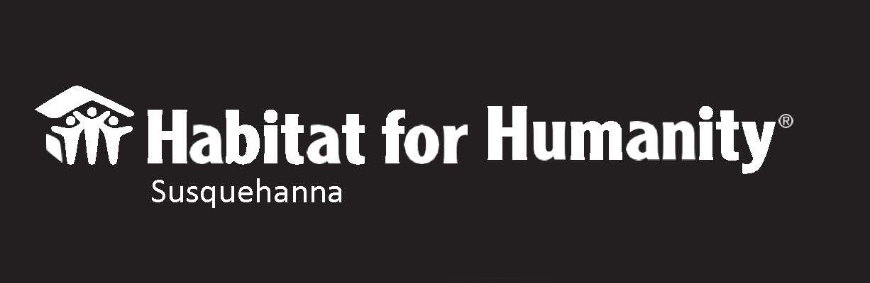
FAQ: Homeownership Program
- Does Habitat for Humanity Susquehanna (HHS) give homes away?
No. Our applicants go through a rigorous qualification process to become approved “Homebuyers”. We provide affordable mortgages geared specifically to the homebuyer’s financial ability to pay.

- Do I have to be a Christian or part of a particular religion to apply for the Homeownership Program?
No. Even though we are a Christian non-profit organization, we do not ask you to conform to any beliefs other than wanting to create a community where everyone has an affordable and decent place to live. We welcome applicants from all backgrounds.

HHS follows a nondiscriminatory policy whereas neither race nor religion are factors in choosing our homebuyers. The only criteria that we abide by are: * The applicant’s level of housing need. * Their willingness to partner with HHS. * Their ability to repay a mortgage made affordable according to their financial capacity.

- If I know my credit is bad, should I wait to apply for the program?
You should not wait. We have FREE financial coaches ready to help you find ways to cut costs, create an action plan, set up a working budget, and many other tips to help you get credit ready and gain financial freedom.

- If I have disabilities, do I still need to complete the Sweat Equity hours?
Yes. We require all approve homebuyers to complete their specified Sweat Equity hours. We will discuss with you what your limitations and abilities are, so we can modify the tasks to ensure that you will succeed in completing your hours.

We may also modify your home to accommodate you or a disabled family member.

- Do applicants have to have children or be married to purchase a home?
No. Applicants are selected on three criteria: 1) Need, 2) Ability to repay an affordable mortgage, and 3) Willingness to partner with HHS.

HHS is an equal housing opportunity provider. We do not discriminate because of race, sex, national origin, religion, familial status, disability, or color.

- If I have filed for bankruptcy, will that disqualify me?
As long as your bankruptcy has been discharged for 3-years or more, then you are eligible to apply for the Homeownership Program.

- Does Habitat for Humanity Susquehanna build only new houses?
We build both - new and rehab existing houses.

- How long does it take to complete the process for purchasing a Habitat home?
The application process usually takes at least 3-months. Once you’re accepted into the program, it can take as long as 12-months beginning to end under “normal circumstances”. If you are in immediate need of housing, we would need to refer you to transitional housing in the county in which you reside.

- Do I get to choose where my house is built?
Once you become an approved homebuyer, we will offer you our next available property. You have one instance of refusal. This means if for some reason you do not accept our first offer, we will offer you the next property in our inventory and then this will be your final offer. You will be encouraged to reapply in 12-months, but no preferences will be given to your previous approval.

- Do homeowners actually own their homes?
Yes, absolutely. Just like any other homebuyer, once settlement happens, HHS turns ownership to the purchasing homeowner. Once the home is completely paid off - we celebrate with a mortgage burning ceremony!

For more details, attend an orientation.

